User guide of Project 4

Run the run.bat in Administration Mode.

**For TA:**

Test Demo WILL BE AT THE END OF THIS DOCUMENT.

During Running Time, The Console will display where I implement the Requirement 2-10.

1. Send Test Request

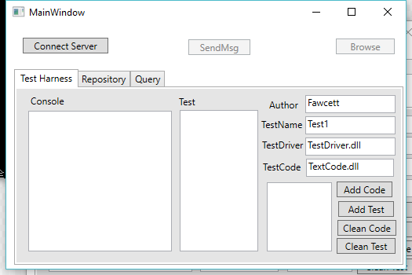

Click “Connect Server”, it will enable “SendMsg”

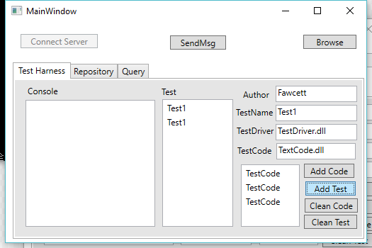

Click “Add Code”, it will copy TestCode Box to Code List. And Click ”Add Test”. It will create a Test and show in the ListBox. And Finally we click “SendMsg”. It will Send the request by Message, including author, TestName, TestDriver, TestCode.

This Application support concurrent running.

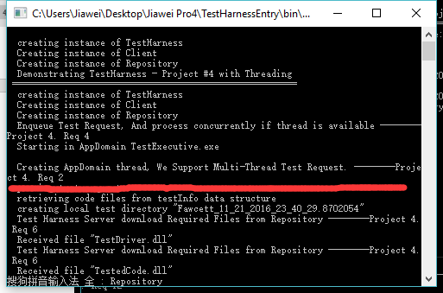

Then, Click “SendMsg”. The GUI will show the log, and the Console will display the running time.

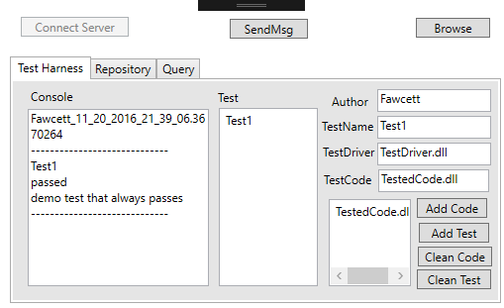

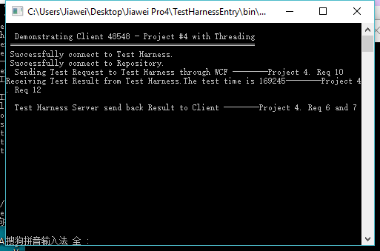

If you start a GUI, there will also a console like figure above, and it will display some information about the test result and the connection between Client and Servers.

But, if in your request, repository has no file you want, it will alert.

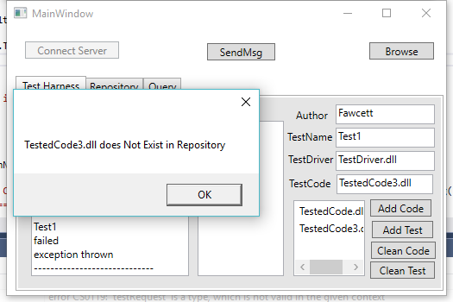

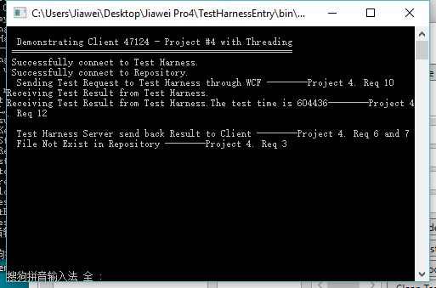

1. Repository

Click “Browse” you can select one or more files, and send to Repository.

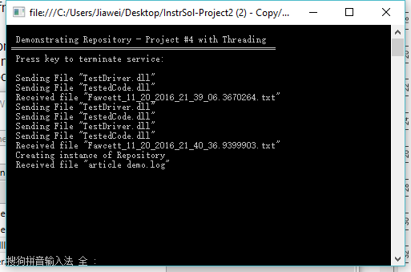

The Repository will show the sending files and receiving files.

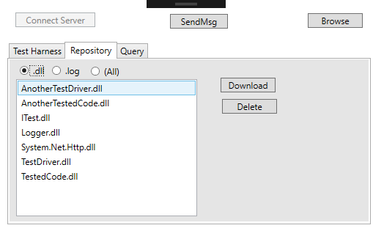

Click “.dll””.txt””(All)”, it will show this type of files.

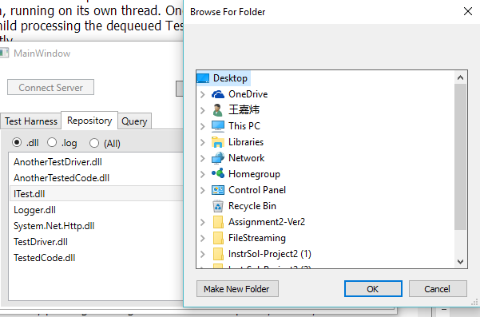

And you can click “Download” , the choose the folder to save the file. Or you can click “Delete”.

1. Query

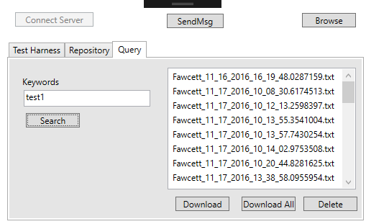

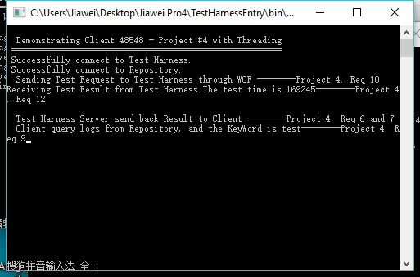

Input the keywords into the TextBox, and click “search”, it will return all the matched logs, and you can choose one item and click “Download”, or you can click “Download All” or “Delete”.

Test Demo:

In this project, We start three projects concurrently. They are Repository, Test Executive and TestHarnessEntry.

In TestHarnessEntry, we will use start two GUI clients concurrently.

And in each client,

1. click “Connect Server”
2. click “Add Code”, “Add Test”. For one test, the test driver is “TestDriver.dll”, test code is “TestedCode.dll”. The other test, the test driver is “AnotherTestDriver.dll”, test code is “AnotherTestedCode.dll”.
3. click “SendMsg”.
4. See the Console and the GUI, it will return a log.

If you want to test if one file does not in Repository

1. click “Connect Server”
2. Change the TestCode Box to other arbitrary value
3. click “Add Code”, “Add Test”. For one test, the test driver is “TestDriver.dll”, test code is “TestedCode.dll”. The other test, the test driver is “AnotherTestDriver.dll”, test code is “AnotherTestedCode.dll”.
4. click “SendMsg”.
5. See the GUI and Console, it will alert “*** do not exist in Repository”